November 2018

Participants:
Glenn Lambert, Jeb Luke, Joel Pita, Joshua Kapusana, Otis Graetz, and Simwinji Sayowa
Group Lab Report
CNC Lathe Project: Munster Tafe Campus

Contents
Abstract 2
CNC Lathes 2
Design Concept (Based on Contract) 2
Some Problems: 3
Design Components & Material Selection 3
Costings 3
Individual Contributions: 4
Z-Axis and Z-axis plates 11
Discussion & Conclusion 15

Abstract
The goal of this project is to design and convert an old lathe into a CNC lathe controlled by servo/stepper motors ran by a computer with CNC software.

CNC Lathes
CNC Lathes are used in industry at an increasing rate as they are more accurate and cheaper to purchase over paying a machinist to work over the lifetime of the lathe.
They work by having a computer run servo/stepper motors to drive ball-screw shafts that the lathe tool is attached to in order to very accurately cut the metal into the desired form. The computer driving the motors runs a CNC software like SOLIDSWORKS’ CAM software or SolidCAM.

Design Concept (Based on Contract)

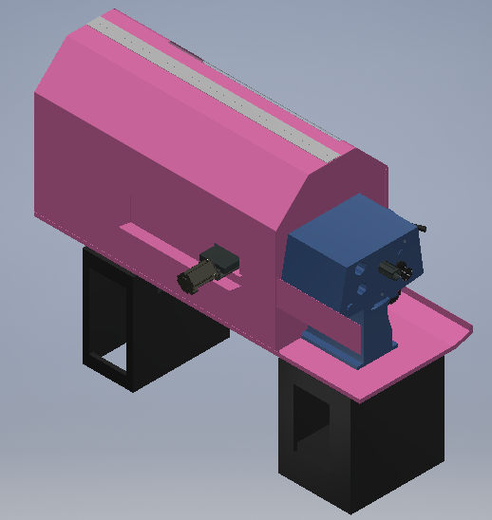
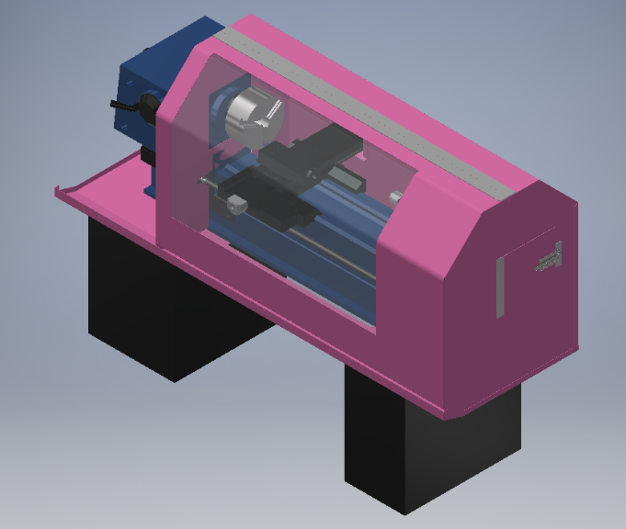
IMAGES/PHOTOS

The work space and parameters given for the lathe are:
- 550 mm length
- 210 mm diameter (will be larger)
- 22-1800 RPM
- Calculated 0.05-0.4 mm/rev feed rate

Some Problems:
- The last group to work on the CNC Lathe made mistakes in measuring the lathe and drawing an accurate model, this has made modelling new component difficult as when measured against the real lathe the dimensions have been of a lot of the time.
- Strict budget, somewhat difficult to get new parts necessary for the project.
- GitHub and student drive access were limited towards the start of our work on the project making any intended modelling or software progress practically impossible.

Design Components & Material Selection
Different parts have been designed based on what is available and what is most practical for completing the project. I.E. The pulley gears are to be printed on a 3D printer and so will be made of ABS plastic. The mounting for the rotary encoder is to be made from aluminium but that isn’t strictly set in stone as mild steel would work just fine for the purpose. The ball-screw mounting for the Z and X Axes are to be made of mild steel as it is readily available and has the rigidity to hold the motors stable against the resistive force of the tool against the work pieces.

Costings
Current Cost for remaining parts: ~$3570.07 + 10 % GST
Working with the material list from the previous class some parts had been purchased and supplied. These were checked to make sure they were correct and fit for purpose
The list was then updated to current requirements and added to for updater drawings to suit modified requirements
Components that were to manufactured in-house and required material were listed for sourcing within the tafe network
Ross will then machine these parts to the component drawings produced for various parts of the lathe
The costings for components were then compiled for Ross to then seek the funds needed to purchase the components required to complete the project. Confirmation of funding has been confirmed and finalisation of the requirements and suppliers is to be forwarded to Gavin for purchase

Individual Contributions:
Glenn:
My part in the project
Otis and I have been working on the Z axis we have had to modify the drawings of the base plate for mounting the servo motor and bearing block
Along with modifying the motor mount bracket and drawing the second bearing mount plate and main bearing housing the represent an accurate drawing
We have done selections and received quotes for the VSD for the main motor and the couplings selection for the Z and X axis
We have had the second Z axis bearing mount modified to suit 10mm bolts as existing in the second plate
I have worked on checking all parts already provided and parts still required.
The spread sheet was updated quotes sourced for major components and a materials list produced for parts to be made in-house
Examples attached
Where is the project going?
Parts are required to be sourced
Drawings are being finalised for manufacture
Materials for in-house parts to be sourced and them machined
Assemble all mechanical parts and then look at the electrical and electronic requirement to make the lathe
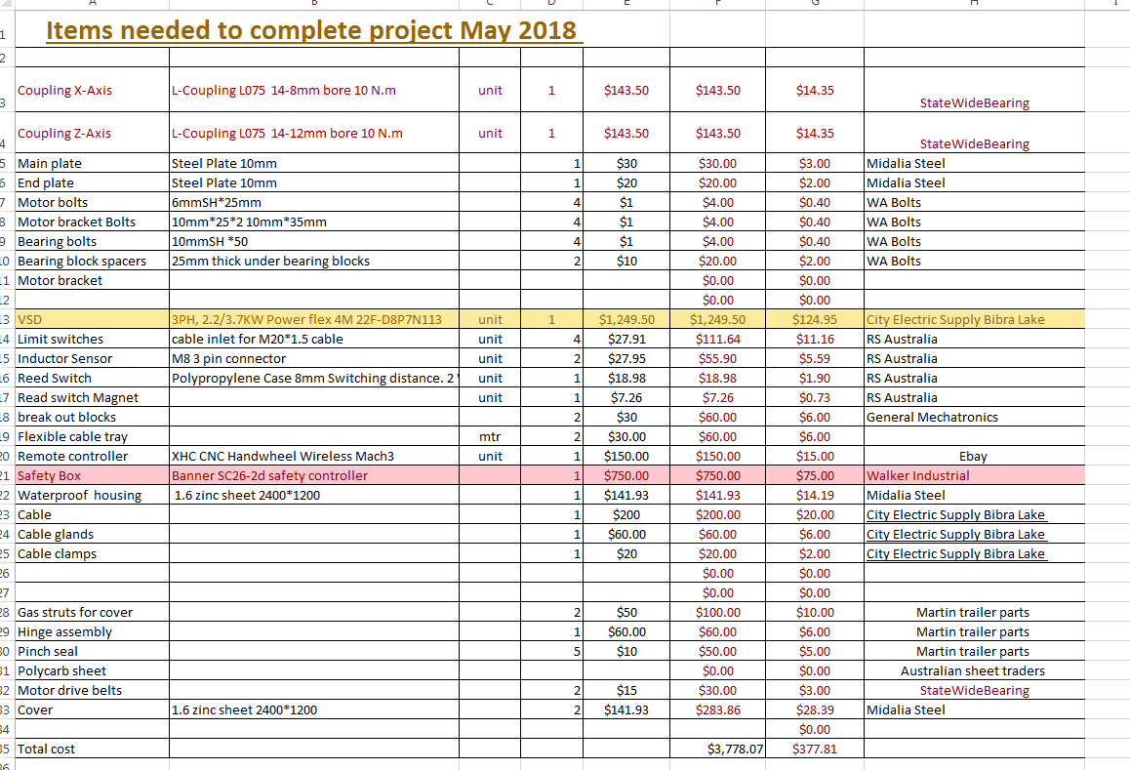
Parts Required

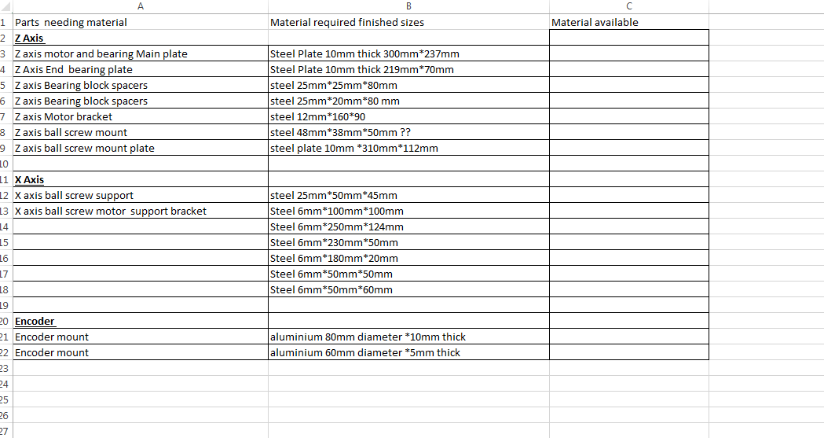
Materials required for in-house parts
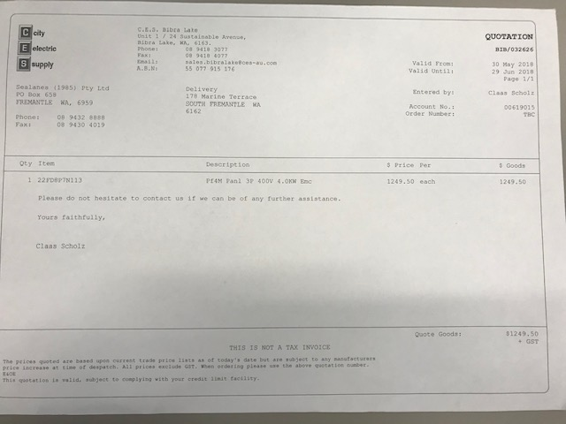

VSD quote

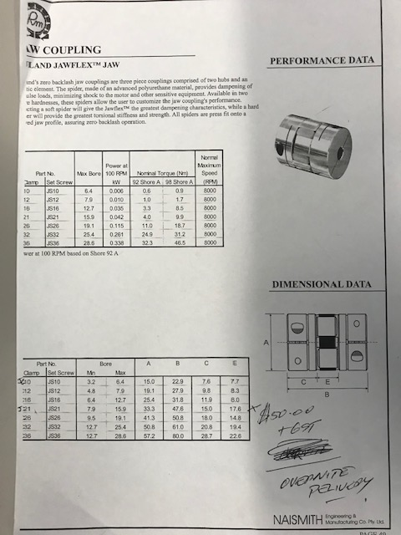

Coupling selection and quote from Precise Motion Products

Jeb: I designed the rotary encoder mounting and pulley setup for it. Remodelled cover in sheet metal.
Rotary encoder pulleys are set at a 2:1 ratio between the shaft and the encoder and use a 3GT toothing setup.
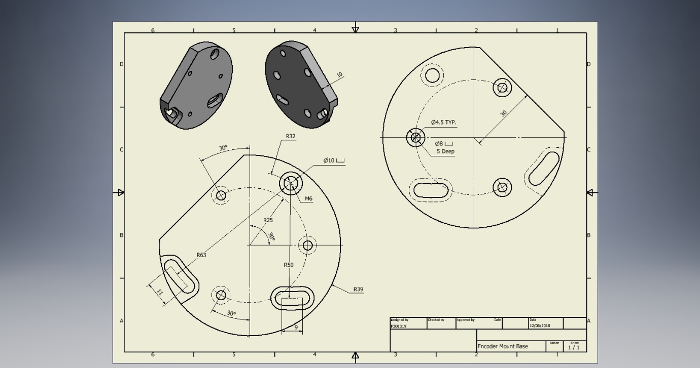
Encoder Mounting Base:

Encoder Mounting Front:
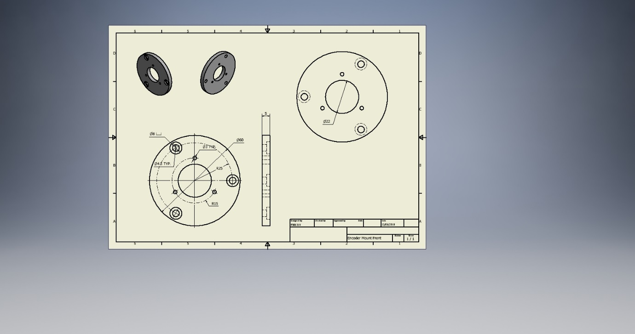

Pulley Gear 70 Teeth:
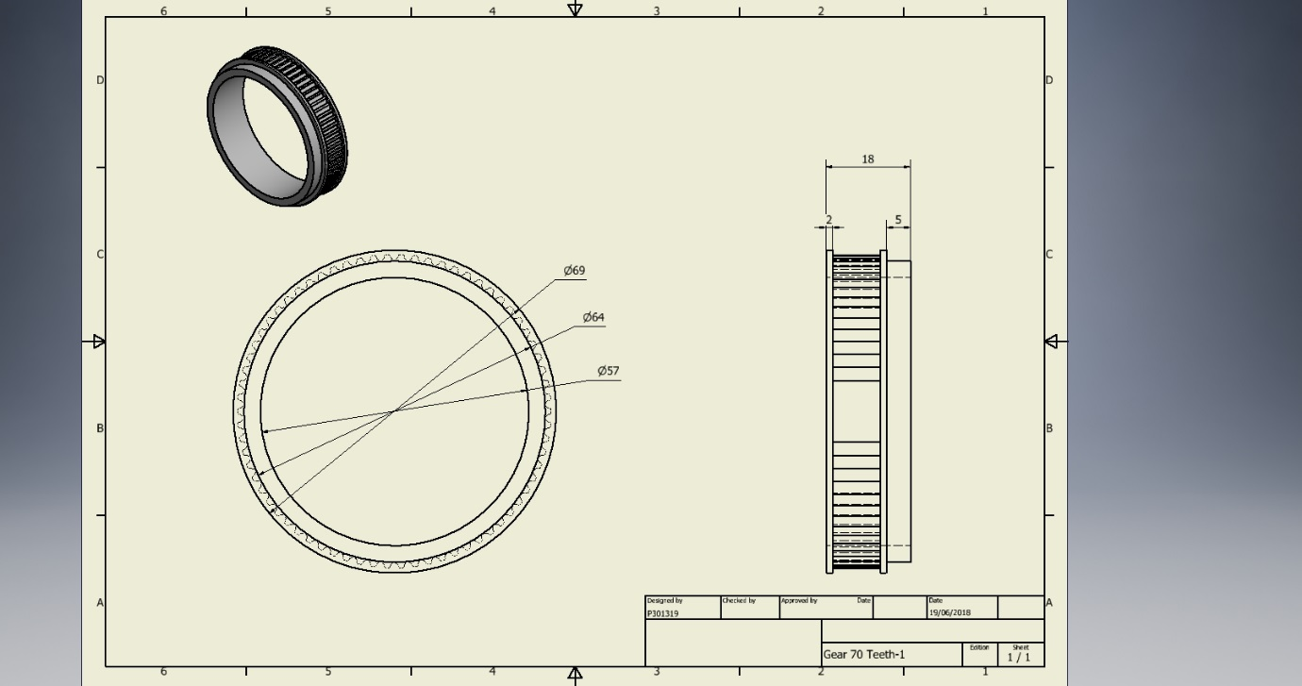
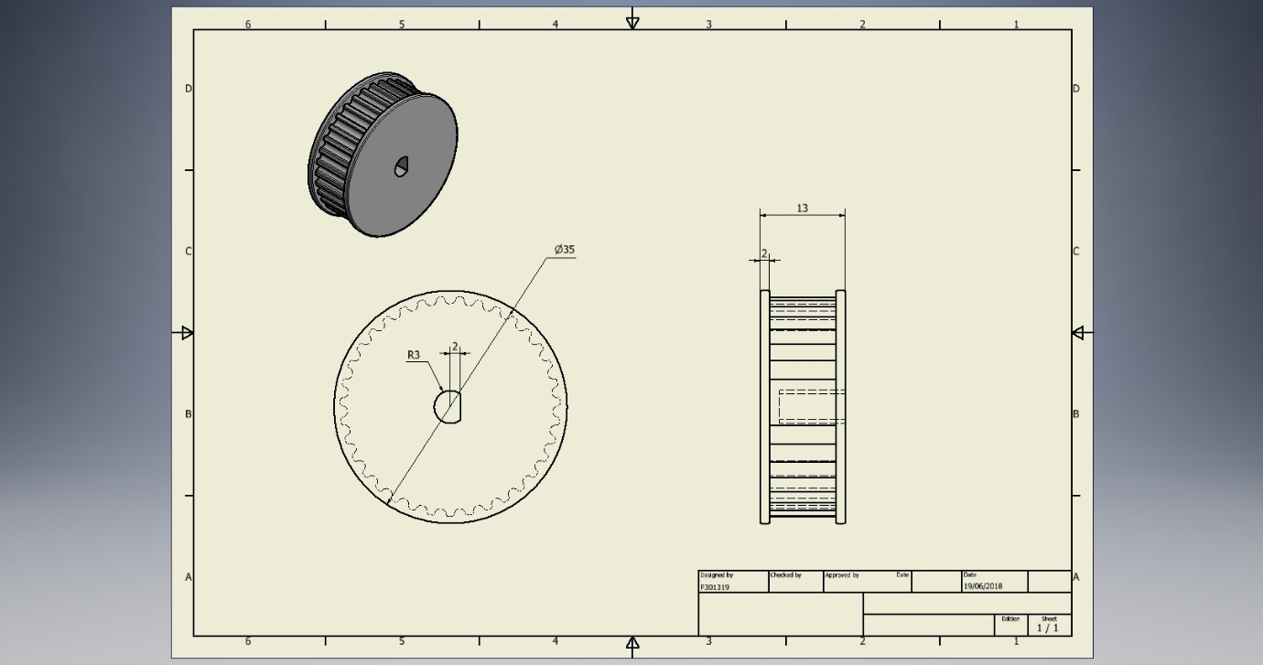
Pulley Gear 35 Teeth:

Joel:
For my part of the project, I was to design the x-axis components, transforming it to CNC from mechanically controlled. This involved:
- Calculating distances and parameters for each components reach to fulfil the 210mm workspace requirements
- Designing components to support necessary parts, such as the bracket for the ball screw and support bracket for the motor
- Adjusting already existing components in order for other parts to comply with the machine. For example, in order for the slide to reach the required distance, I had to improvise and place the ball screw under the slide. Doing so created another problem with clearance, which was solved by machining the underside of the slide.
- Consulting with Ross with parts that need to be machined. One part in particular was the motor support. My current design at the time was focused on the supporting as large load which was unnecessary, as the machining would be more time/material consuming than necessary
The result of the transformation was a success (in Inventor at this stage), as everything fits and works nicely with other components of the lathe.
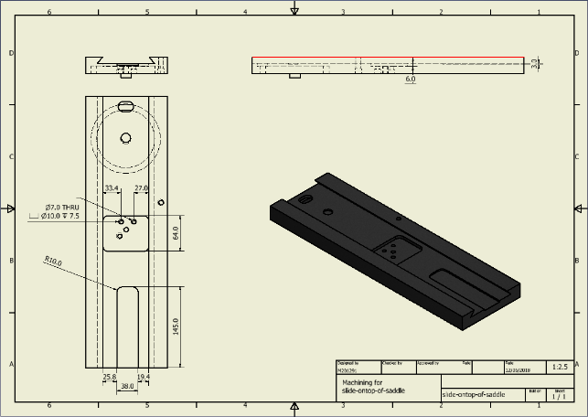
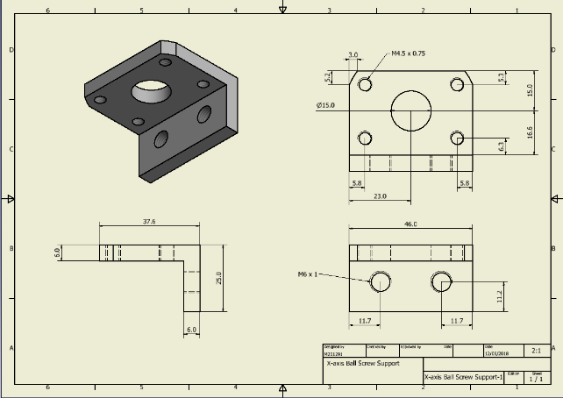
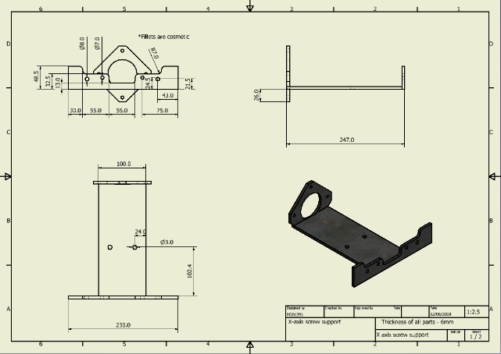
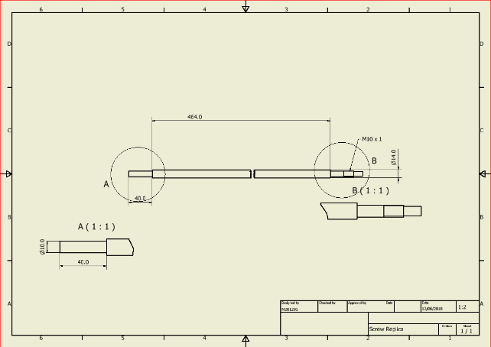

Joshua:
Cover
Initial version of cover

A design of the cover was handed over by the previous group but it was not ideal in regards to its appearance and suitability for its intended function on the lathe machine. Hence a new cover was needed to enclose the working area and prevent the coolant from splashing out. This task was allocated to two members of the design team. An initial concept of the cover was made. Below is a rough sketch of the initial concept before changes were made.

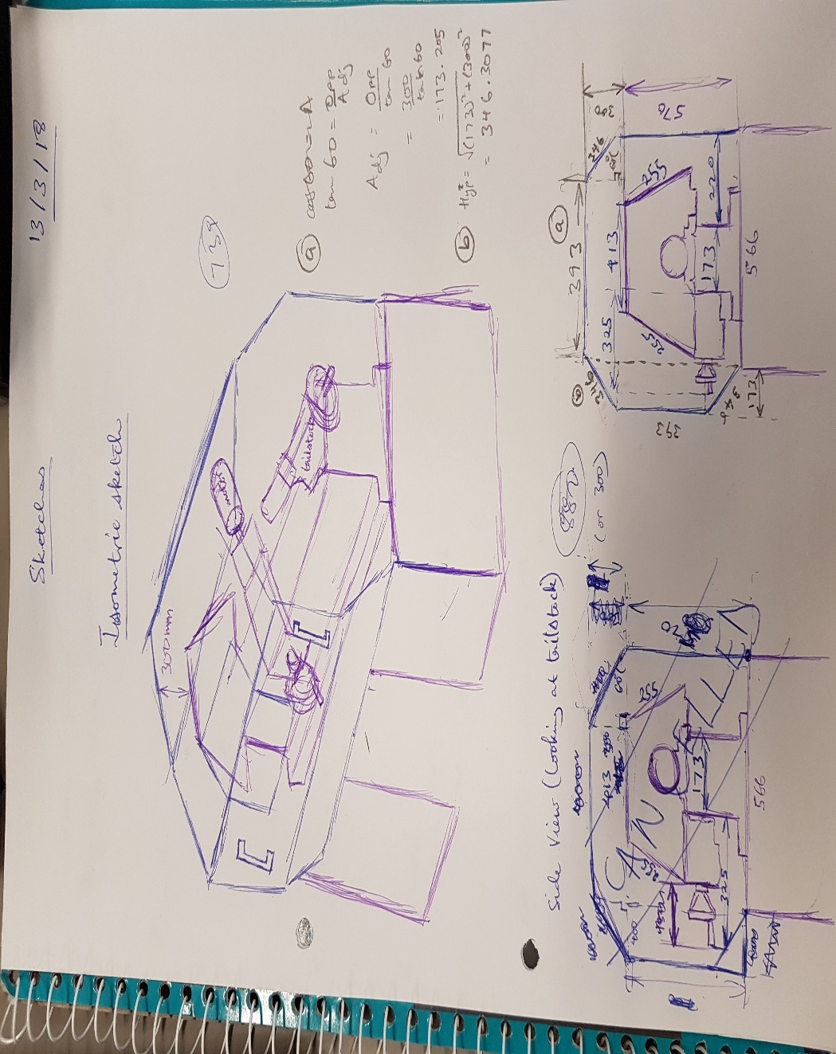
Changes were made to the initial design in order to change the position of the hinge to make the cover easier to open and also to improve the appearance of the cover. The cover was to be constructed out of 1.6mm Zyncalune and the window was to be made out of 4mm Polycarbonate. Considering the above, different parts of the cover were designed and modelled on computer. Drawings of some of the modelled parts have been generated as seen on the next page of this report. Calculations have also been made to select suitable pneumatic gas struts for the operation of the cover. The gas struts are required to correspond with the approximate load that the will bear.

Final version of cover
Additional changes were made to the cover. The design for the door next to the tailstock was completed and steel plates were added next to the opening for the X axis motor. Both these changes were made to improve the covers ability to contain coolant including the extending the cover base. Below are images of the final cover version and further reference can be made to the drawing files.

Otis:

Z-Axis and Z-axis plates
Plates, Shafts, Mounts & Design
Throughout the designing phase of this project Glenn & I were with the Z-Axis which the previous group before us had started. With consultation with Tom (Technician) we decided to resign the entire Z-Axis to simplify the motor mount and ball screw mounting plates this also meant we did not have to modify the lathe base, we did a complete resign of the mounting plates as we removed the complete apron assembly from the front of the machine to make it easier when mounting and servicing the Z-axis easier. In the pitches below you can see the clear changes that were made to mount & support plates as well as adding the apron plate to be able to mount the Z-axis to the bottom of the saddle.

Old & New Motor Mount Fins

Old motor support fin

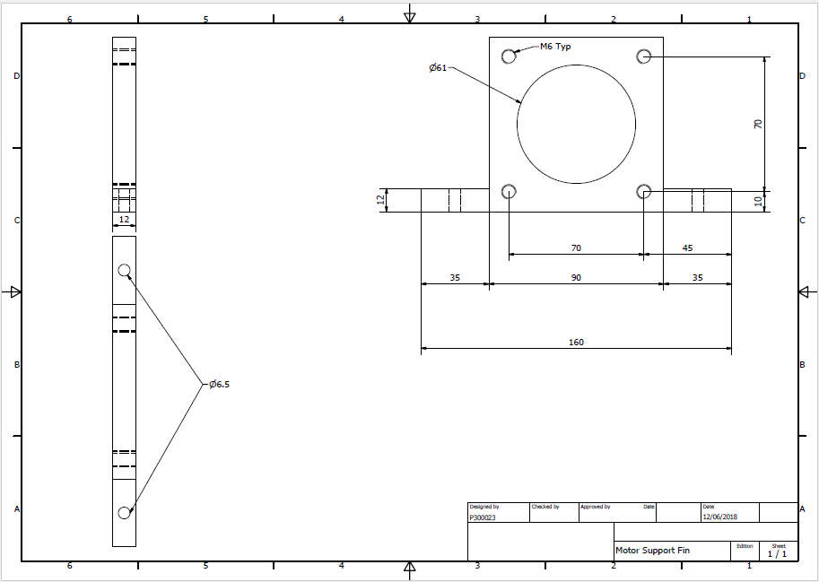

New motor support fin

Old & New Ball Screw Bearing Block Plate

Old ball screw bearing block plate

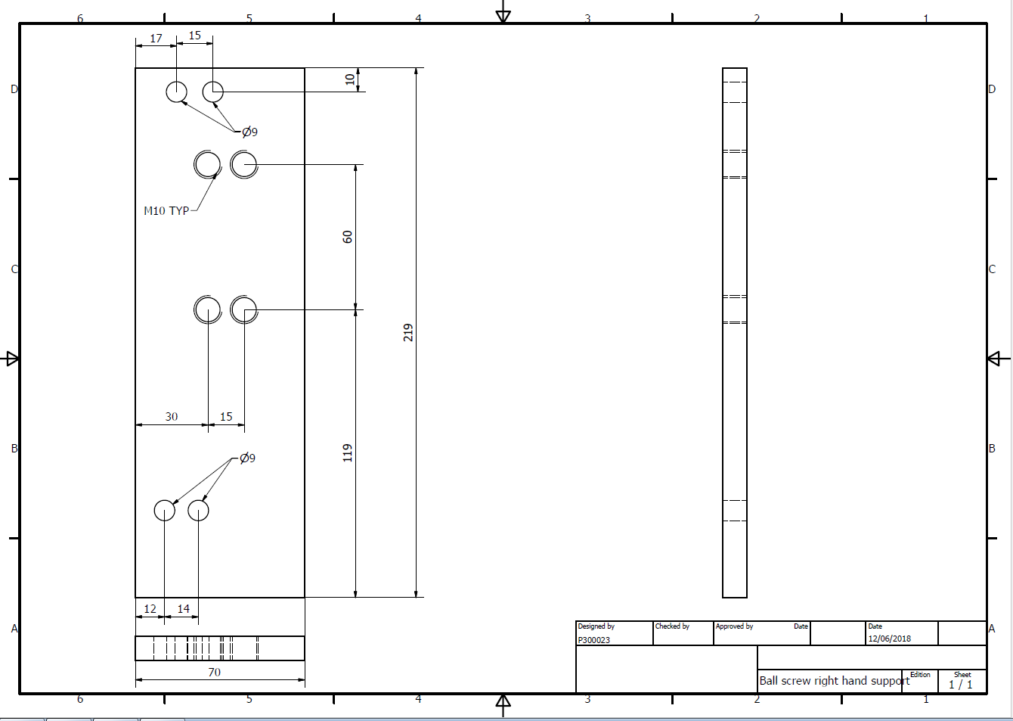

New ball screw bearing block plate

Motor Mount Base Plate

Old motor support plate

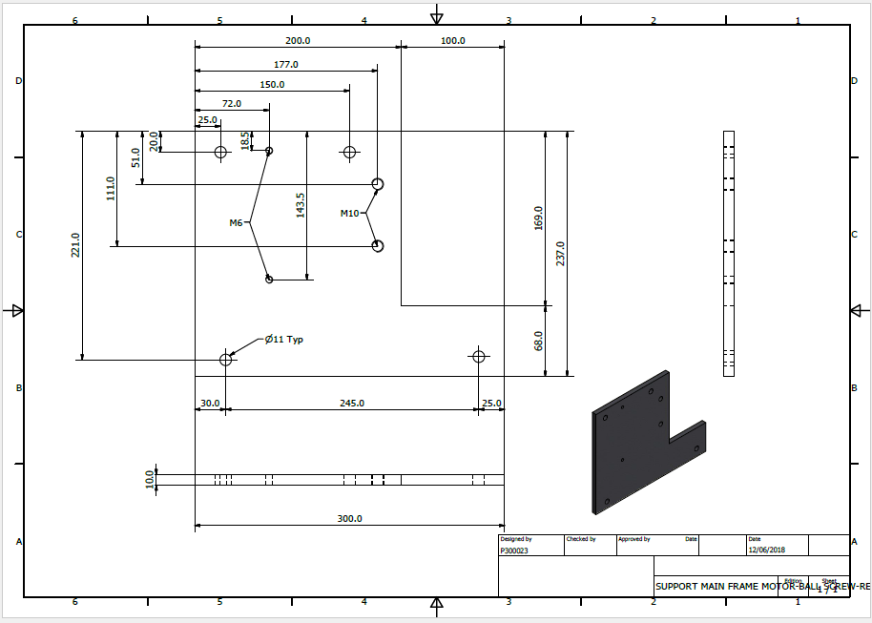

New motor support plate

Apron Base Plate
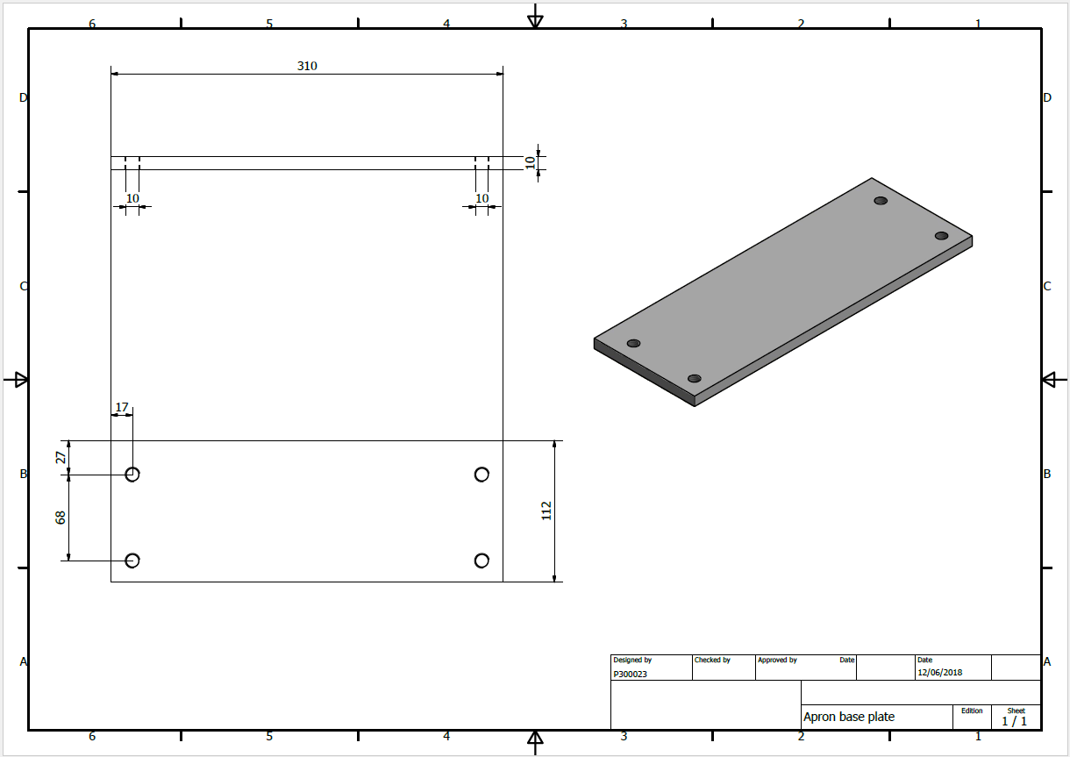

Simwinji:
Personal Contribution
On an individual contribution, I was paired with Joshua Kapusana to design the cover of the Lathe Machine. From the previous project, the cover was designed but not suitable for the new project. For this reason, we took measurements on the actual machine in order to make a new design of the cover.
The cover of the machine has basically 5 parts; the front and back plates, the two side plates as well as the piano hinge. All these parts were drawn separately and assembled as one cover. I and my partner Joshua worked hand in hand to put everything together.
Most of the sketching was done by Joshua and I did most of the drawing using Autodesk Inventor. The pictures below are the parts of the Lathe Machine cover.
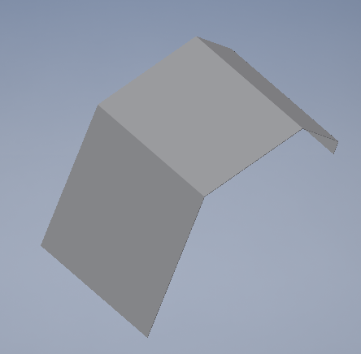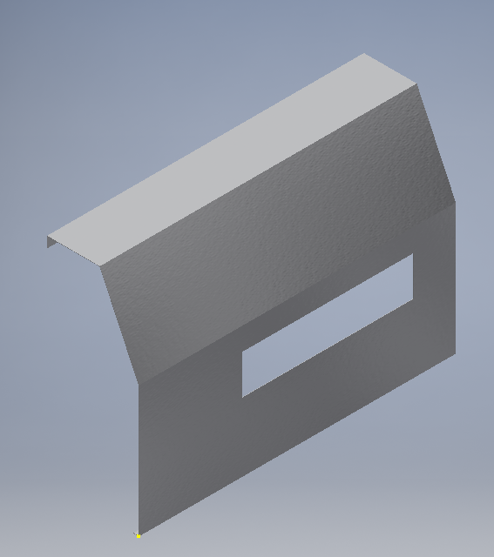
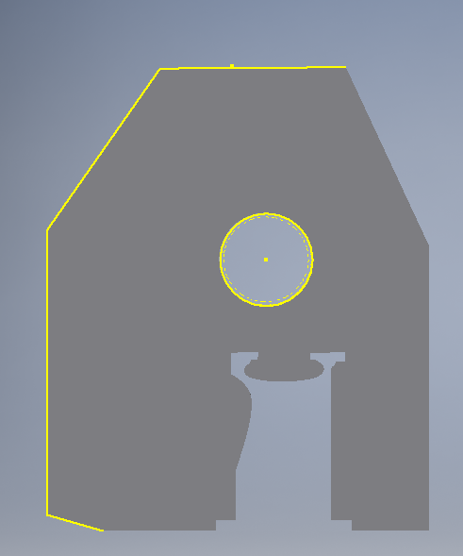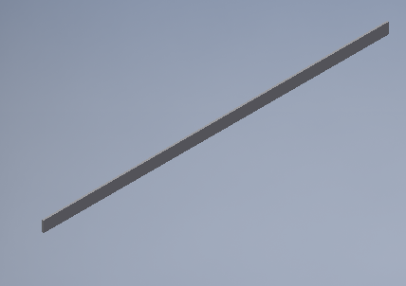
The specifications of the design are;
Length: 1200mm
Height: 811mm

Discussion & Conclusion
We will probably not be able to complete the project by the end of the year.

